BDSH Wireshark Report – Evidence01.PCAP

This is an example report for a PCAP analysis from a team member of BDSH and does not include any AI analysis.
Contents
Summary of investigation 1
IP addresses and MAC 1
Forensic Process 1
Figure #1 - Conversation 2
Figure #2 - Meetup Location 3
Figure #3 - Packet information. 3

Summary of investigation
The evidence01.pcap file contains an email conversation between two individuals in a conversation that seeks to plan a meeting between the two. It involves a person referred to as Ann Dercover messaging from a device name Ann laptop (<000901ca49ae$89d698c0$9f01a8c0@annlaptop>) under the email <sneakyg33k@aol.com> from the Ip address 192.168.1.159, and another individual only referred to as “sweetheart” with the email mistersecretx@aol.com. These two individuals have organised to meet up at Playa Del Carmen, which is a costal resort town on the east side of Mexico.

IP addresses and MAC
192.168.1.159 – Dell_4d:4f:ae (00:21:70:4d:4f:ae) - Sneakyg33k@aol.com – Private address
64.12.102.142 - Public address located in Los Angeles, California
192.168.1.10 – Private address
192.168.1.30 – Private address
192.168.1.255 – Private address
10.1.1.20 – Private address

Forensic Process
The main key content found inside of the file ‘evidence01.pcap’ was the conversation (figure 3 page 3) between two different individuals, as well as the location of the secret rendezvous point. Our process started with looking at the IPv4 statistics to see which IP addresses were of most interest to us. Following this we extracted the files from the PCAP using export objects under EMF files, this led us to the packets containing the email files (figure 1 page 2) where information regarding the location of the secret meetup is kept, we know this because we extracted the ‘secretrendevous.docx’ file from the email conversation and decoded the information using base64 decoder which provided us with the details (figure 2 page 3).

Figure #1 - Conversation
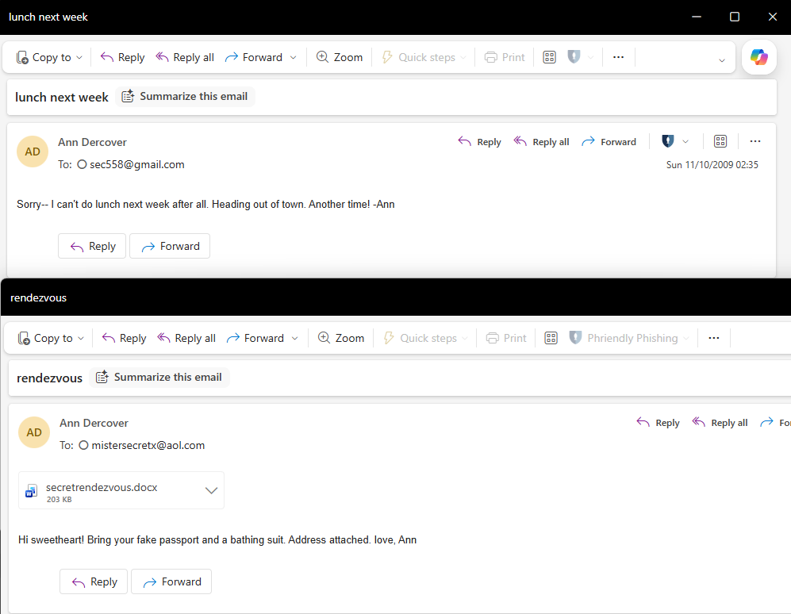

Figure #2 - Meetup Location
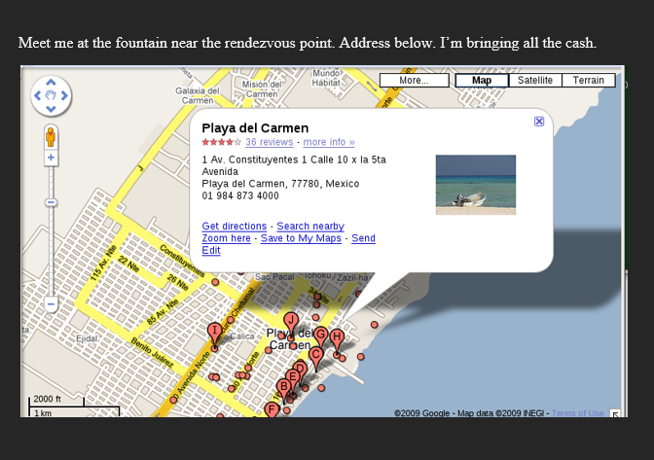
Latitude: 20.646285 | Longitude: -87.080787.

Figure #3 - Packet information.
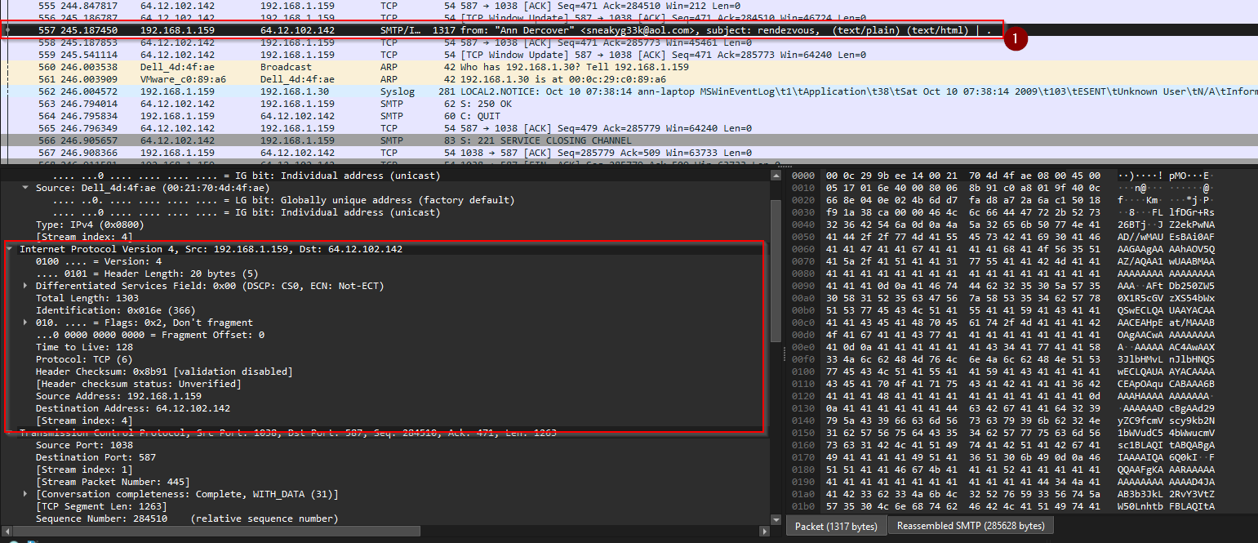

Estimated time to analyse document and write report ~4 hours

